**Test Cases**

*Test Case 1: Entire form is left blank.*

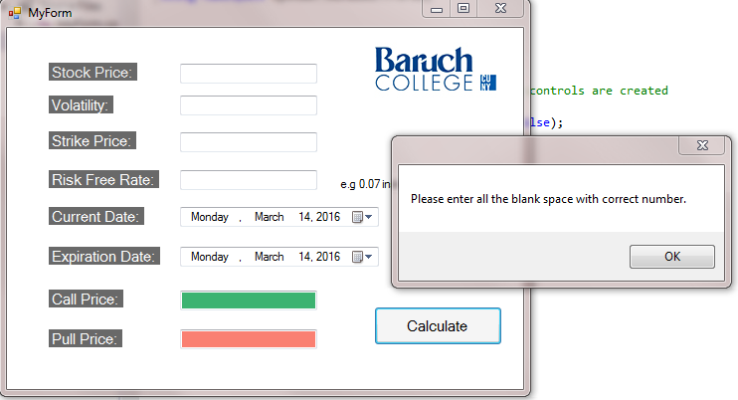

*Test Case 2: Volatility is expressed as a whole number.*

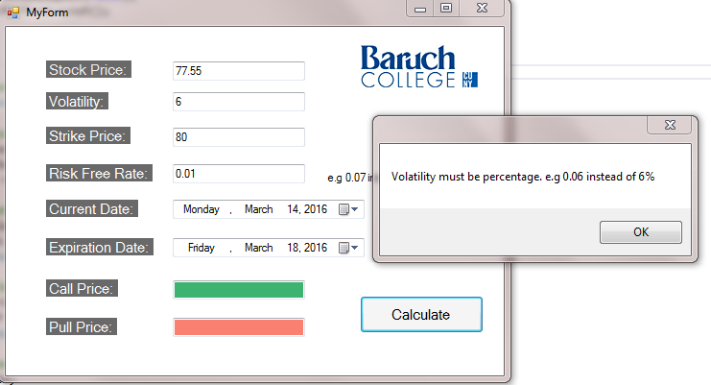

*Test Case 3: Expiration Date is before Current Date*

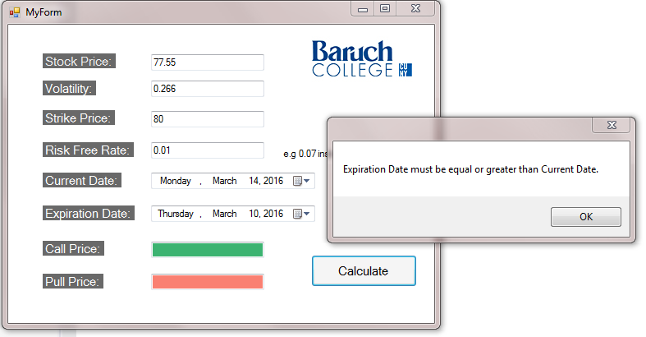

*Test Case 4: Completed calculation*

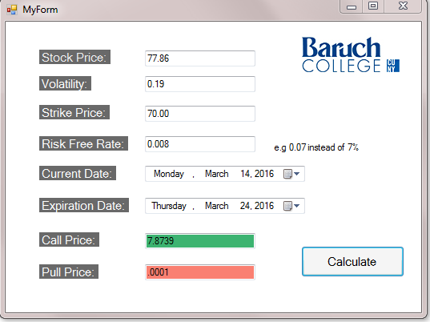

*Test Case 5: Completed calculation with Volatility doubled.*

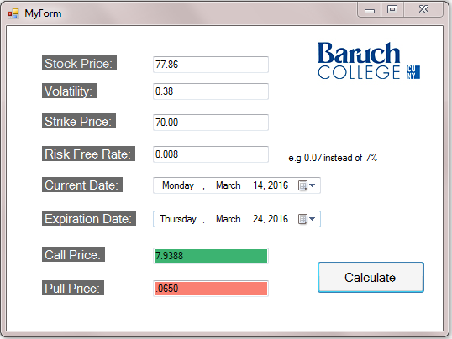

*Test Case 6: Completed calculation with double the time to maturity.*

